**Assessment**



**D111-Database Fundamentals**

**Assessment Two (Practical Assignment)**

|  |  |  |
| --- | --- | --- |
| **Due Date**  Sunday 14th June | **Faculty**  Humanities and Business | |
| **Due Time**  11.55 PM | **School**  Business and ICT | |
| **Weighting**  35% | **Programme**  Bachelor of Information and Communications Technology (Applied) | |
| **Submission Method**   * Upload to Moodle. | **Learning Outcomes Assessed**   * Construct a simple relational database using a Database Management System | |
| **Conditions**   * **Must be your own work** |  | |
| **Lecturer**  Richard Dargie | | **Moderator**  Sandra Cleland |

**Requirements**

You need to create a database prototype using MS Access, based on the documentation provided and the requirements outlined below.

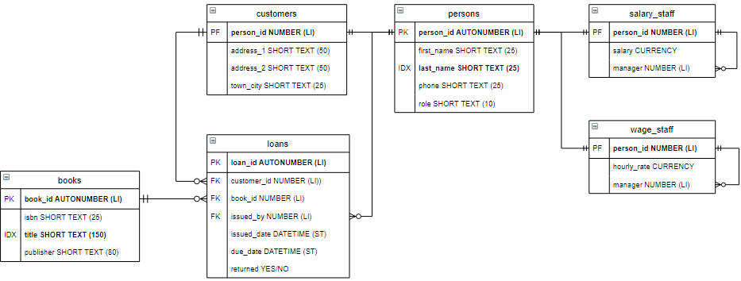

# Tables

* Examine the ERD provided and create the tables necessary to build a database prototype.
* Use our Physical Design class naming conventions.
* Set the Data Types, Primary Keys, Foreign Keys, and Indexes, Character sizes as indicated). “DATETIME (ST)” stands for “short date”. As shown on the ERD provided.
* Create relationships between the tables according to the ERD provided and what you deem is necessary to complete the assignment.
* Where appropriate, implement *referential integrity* on your relationships.
* Examine the data provided in table format below, and populate the appropriate tables with that data. (Provide your own customer data and loan test data).

|  |  |
| --- | --- |
|  |  |
|  |  |
|  |  |

# Forms

For all forms except the loan subform

* Must be based on a template so they have a standard layout and colour scheme (You can use your own colour scheme).
* Have a working “Close Form” button.
* Match the layouts according to screenshots provided (Labels, Text Field, Combo Box, Button locations).

# The Switchboard Form

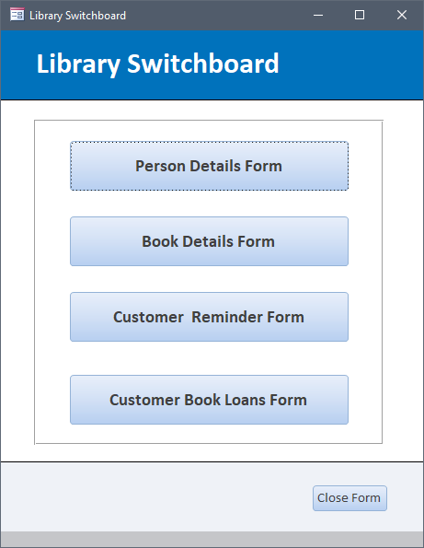

* Must automatically show running in Form View as soon as the database is opened.
* All four buttons open the respective forms as depicted in the captions.

# The Book Details Form

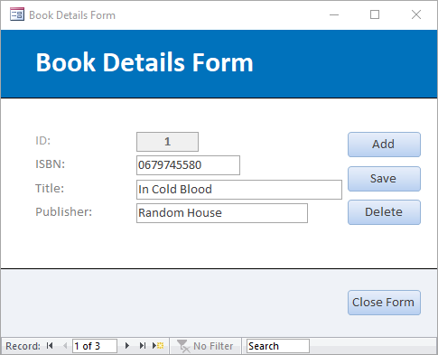

Figure 2 Book Details Form

* Able to *add*, *save* and *delete* book data.

# The Person Details Form

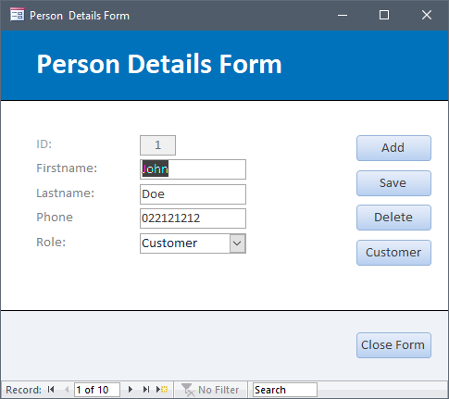

Figure 3 Person Details Form

* Able to *add*, *save* and *delete* person data.
* The *person* records are navigable.
* The role Combo box must contain values that can be entered by the user (not from a query or table). The three values are; [Customer, Salary and Wage]. The role values must save to, and display from, the person table’s role field.
* The form contains three buttons that appear according to the value displayed in the Role: Combo box
  + If the value is “Customer”, then the Customer button displays.
  + If the value is “Salary”, then the Salary button displays.

|  |  |  |
| --- | --- | --- |
| Figure 4 No button. | Figure 5 Customer button. | Figure 6 Salary button. |
| Figure 7 Wage button. |  |  |

* + If the value is “Wage”, then the Wage button displays.
  + If the value is empty (i.e. when adding a new person), no button is displayed.

# The Customer Details Form

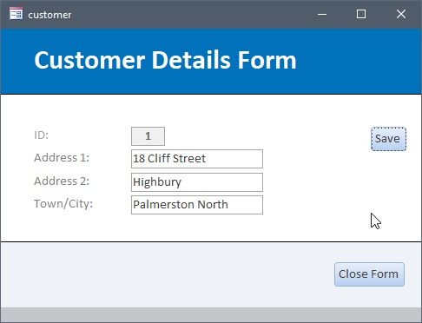

* If on the Person Details Form, the Customer button is clicked, the Customer Details Form must open.
* The Customer Details Form’s ID text box value, must match the corresponding ID number from within the Person Details Form’s text box.
* Be able to save customer data into the customers table.
* Navigation Buttons are NOT displayed.
* The customer data is populating all text box fields.

# The Salary Staff Details Form

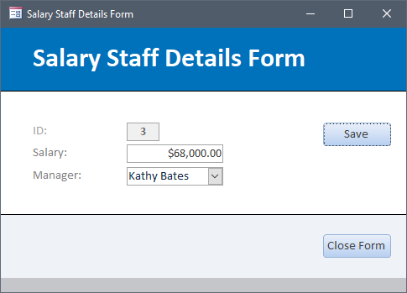

* If on the Person Details Form, the Salary button is clicked, the Salary Staff Details Form must open.
* The Salary Staff Details Form’s ID text box value, must match the corresponding ID number from within the Person Details Form’s text box.
* Be able to save salary staff data into the salary_staff table.
* Navigation Buttons are NOT displayed.
* Salary staff data is populating all text box and Combo box fields.
* The Manager Combo box shows the full name of the person that manages them, but stores the number in the salary_staff table.

# The Wage Staff Details Form

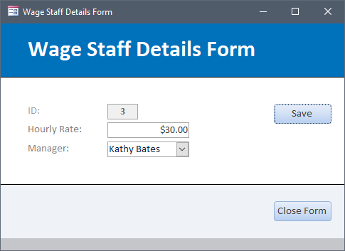

* If on the Person Details Form, the Wage button is clicked, the Wage Staff Details Form must open.
* The Wage Staff Details Form’s ID text box value, must match the corresponding ID number from within the Person Details Form’s text box.
* Be able to save wage staff data into the wage_staff table.
* Navigation Buttons are NOT displayed.
* Wage data is populating all fields.
* The Manager Combo box shows the full name of the person that manages them, but stores the number in the wage_staff table.

# The Customer Reminder Form

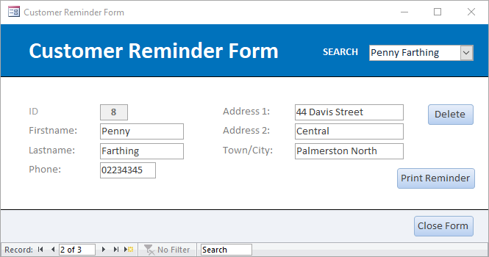

* All details about the customer are shown in the form.
* When a customer name is selected from within the Search Combo box, a customer is filtered in the form with details that match the name selected.
* The customer records are navigable.
* The Search Combo box must display the full names of the customer in the Combo box (see the example above).

# The “Print Reminder” button

* When the Print Reminder button is clicked, a Print Preview report is displayed in modal view, which is filtered to the current customer displayed on the form (see below).

# The “Print Reminder” Report

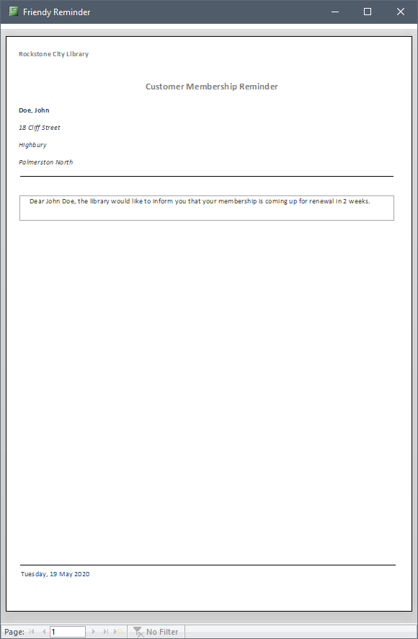

# The “Print Reminder” Report

* The report must be based on a query.
* The report must include the use of Page Header and Page Footer sections.
* The report must demonstrate grouping by person_id.
* The statement that reads:  
  

Must be generated entirely from the query the report is based on (do not embed the customer name in the statement within the report)

* The customer’s fullname shown above the address details, must be created in the query.
* The report must have a similar layout to the above example.

# The Customer Book Loans Form

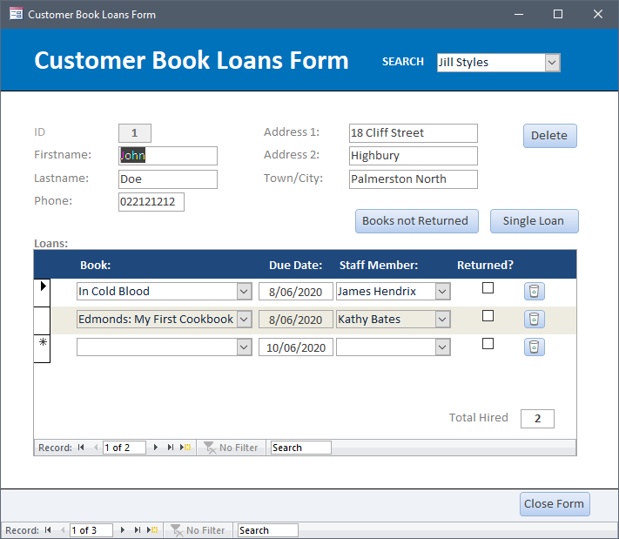

* All details about the customer are shown in the outer Customer Book Loans Form.
* When a customer name is selected from within the Search Combo box, a customer is filtered in the outer Customer Book Loans Form with details that match the name selected AND, the data displayed in the loans subform is filtered for that customer only.
* The customer AND loan records are navigable.
* When navigating through outer Customer Book Loans Form’s customer records, the loans subform records must be synchronised to that current customer.
* The Search Combo box must display the full names of the customer in the Combo box (see the example above).
* The Delete button deletes ONLY the current customer and their associated loans.

# The Loans Subform

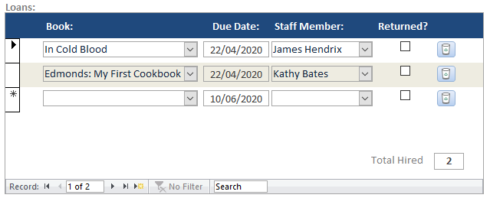

* Must synchronise with the outer Customer Book Loans Form customer details.
* The Book Combo box must show all three titles, but store the book_id number in the loans table. (We are not trying to show only available books in this Combo box. That is outside the scope of this assignment).
* The Due Date value is automatically calculated based on the current date plus 21 days (The user should not have to enter this in manually).
* The Staff Member Combo box must show the fullname of only the wage and salary staff persons. The name must appear but the person_id is stored in the loans table.
* A single loan record is able to be deleted via the delete button beside each loan record.
* The number of hires for that customer are shown in the forms footer.
* If a customer is deleted, the loan/s for that customer are also deleted.
* The “Returned?” checkbox values are stored in the loans table. These are also used to filter the “Books not Returned” report
* The loan record is successfully saved to the loans table.

# The “Books not Returned” Button

When the “Books not Returned” button is clicked, a Print Preview report is displayed in modal view, which is filtered to the current customer displayed on the form AND displays ONLY the books that are not returned (unchecked). See below:

# Books not returned Report

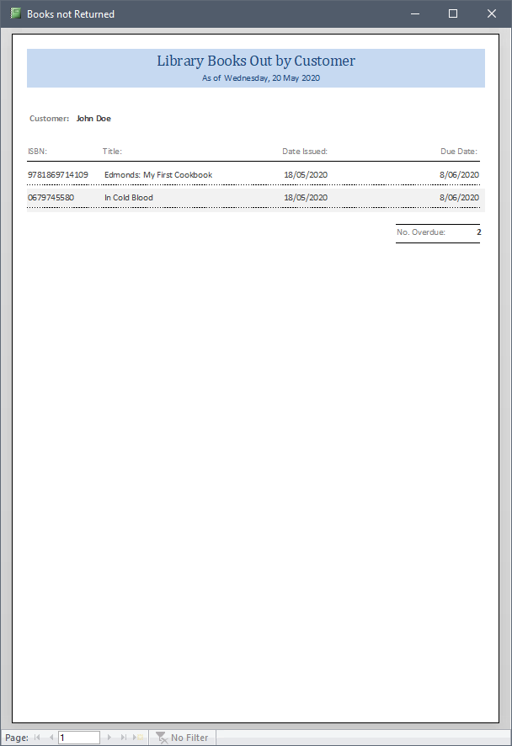

# The “Books not Returned” Report

* The report must be based on a query.
* The report must include the use of a Report Header section.
* The report must demonstrate grouping by person_id.
* Within a Group Footer section, display the number of books not returned
* The customer’s fullname must be created in the query.
* The report must have a similar layout to the above example.
* The report shows the correct number of books not returned (matching the information from the form)

# The “Overdue” Button

When the “Overdue?” button is clicked on the Main Customer OUTER form, a Print Previewreport is displayed in modal view. This report is filtered to the current customer displayed on the form AND displays ONLY a single loan record that is selected using the Record Selector button to the right of that loans subform record. See highlighted below:

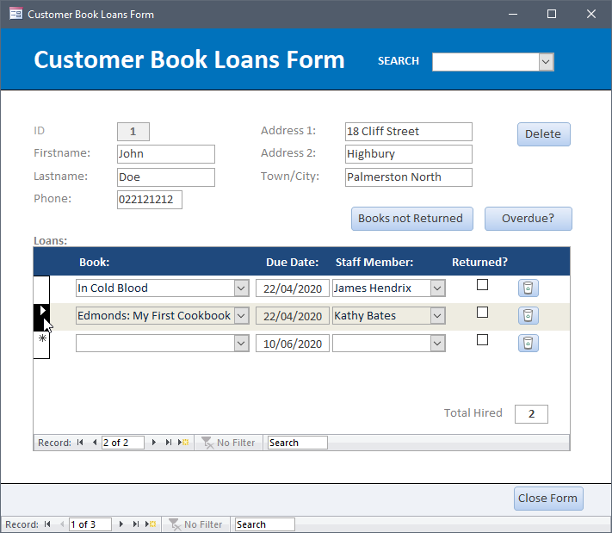

# The “Overdue” Report

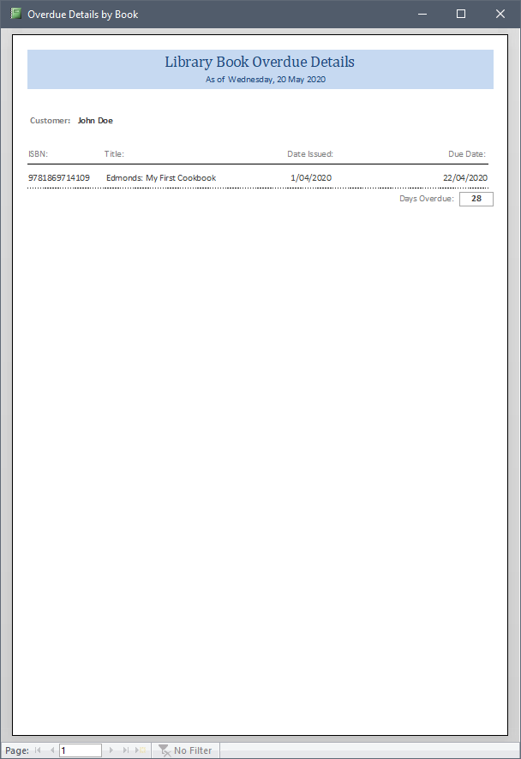

* The report must be based on a query.
* The report must include the use of a Report Header section.
* The report must demonstrate grouping by person_id.
* The Group Footer must display the number of days that book is overdue. If it is not overdue then the days will display with a “-“(minus) in front of the number. Use a MS Access DateDiff function to achieve this, and place the code in an unbound textbox.
* The customer’s fullname must be created in the query.
* The report must have a similar layout to the above example.

# **Marking Guide**

* Grade allocation will be the lecturer’s discretion.

To obtain a **C grade** for this assignment you must ensure your database prototype has met the above requirements for the following above sections:

1. Tables
2. Forms
3. The “Switchboard Form”
4. The “Book Details Form”
5. The “Person Details Form”
6. The “Customer Form”

To obtain a **C+ grade** for this assignment you must ensure your database prototype has **met the C grade** requirements, AND your database prototype meets the requirements for the following sections:

1. The “Salary Staff Form”
2. The “Wages Staff Form”

To obtain a **B- grade** for this assignment you must ensure you have **met the C grade** requirements, AND your database prototype meets the requirements for the following sections:

1. The “Customer Reminder Form”
2. The “Print Reminder” Button
3. The “Friendly Reminder” Report

To obtain a **B grade** for this assignment you must ensure your database prototype has **met the C+ grade** requirements, AND your database prototype meets the requirements for the following sections:

1. The “Customer reminder Form”
2. The “Print Reminder” Button
3. The “Friendly Reminder” Report (**minor layout issues**)

To obtain a **B+ grade** for this assignment you must ensure your database prototype has **met the C+ grade** requirements, AND your database prototype meets the requirements for the following sections:

1. The “Customer reminder Form”
2. The “Print Reminder” Button
3. The “Friendly Reminder” Report

To obtain an **A- grade** for this assignment you must ensure you have **met the C+ grade** requirements, AND your database prototype meets the requirements for the following sections (**but has minor issue**):

1. The “Customer Book Loans Form”
2. The “Loans Subform”
3. The “Books not Returned” Button
4. The “Books not Returned” Report

To obtain an **A grade** for this assignment you must ensure you have **met the C+ grade** requirements, AND your database prototype meets the requirements for the following sections:

1. The “Customer Book Loans Form”
2. The “Loans Subform”
3. The “Books not Returned” Button
4. The “Books not Returned” Report

To obtain an **A+ grade** **(85%)** for this assignment you must ensure you have **met the A- grade** requirements, AND your database prototype meets the requirements for the following sections:

1. The “Books not Returned” Button
2. The “Books not Returned” Report (**has minor layout issue**):

To obtain an **A+ grade** **(100%)** for this assignment you must ensure you have met the A grade requirements, AND your database prototype meets the requirements for the following sections:

* All sections **fully met** (Lecturers discretion)

# DUE Date:

BEFORE UPLOADING – Within MS Access run “Compact & Repair Database” on your database:

